Animation Laser Light

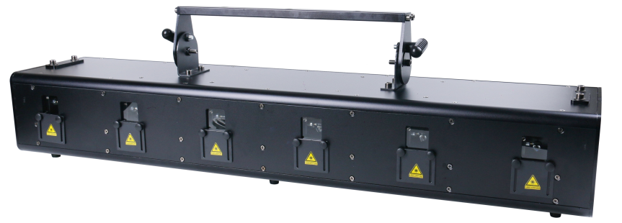

Please read this manual carefully before use!

Contents

Introduction And Caution------------------------------------------------------------P2

Symbol Instruction And Safety Instruction--------------------------------------P3

Installation Instruction----------------------------------------------------------------P4

Product Specification & Display operation---------------------- -----------------P5

Menu Operation------------------------------------------------------------------------P6

MENU function setting ---------------------------------------------------------------P6

DMX Channel Instruction-------------------------------------------------------------P7~P11

DMX Connection&and address setting ------------------------------------------P11-12

Cleaning, maintenance, attention--------------------------------------------------P13

Warranty card---------------------------------------------------------------------------P13

Thank you for your patronage. We are confident that our excellent products and service can satisfy you. For your own safety, please read this user manual carefully before installing the device.

In order to install , operate, and maintain the light correctly, we suggest that the installation and operation should be done by the verified technician with following the instruction strictly.

This moving laser bar’s output is amazing. It is well designed with professional aluminum alloy housing. It makes full use of the advanced electronic positioning technology, and with international standard DMX512 control system. It is ideal for TV show, disco, dancing hall, night club, stage...and some applications outdoor.

Parts inside the box:
Item | Quantity | Unit
Light fixture | 1 | pc
User Manuel | 1 | pc
Power Cable | 1 | pc
DMX connection cable | 1 | pc
Handle | 1 | pcs

Please check carefully that there is no damage caused by transportation. Please contact your local dealer if any problem.
Caution
Before leaving the factory, this unit has passed strict inspection, functions stable and perfect packing. If this unit is operated in any way different to the one described in this manual, the product may suffer damages and the guarantee becomes void. Furthermore, any other operation may lead to dangers like short circuit, burns, electric shock, crash etc. If any technology changes of this manual, company do not notice in further and have interpretation.



CAUTION!

Keep this device away from rain and moisture!

Unplug mains lead before opening the housing!


Warning!

Damages caused by the disregard of this user manual are not subject to warranty. The dealer will not accept liability for any resulting defects or problems.

Symbol Instruction On The Device
……………………………………………………………

…

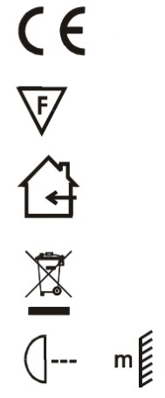
CE Certificate
………

…

……………………………………………………

…

……………………………………………

…

…………………

…

Suitable directly installed on the common combustible materials devices
Only indoor using
Environmental protection
The minimum distance from lighted objects(meter)
Safety Instructions

This unit was in perfect condition before leaving factory. In order to maintain this condition and to ensure a safe operation, it is absolutely necessary for the user to follow the safety instructions and warning notes written in this user manual.

►Unpack and check carefully there is no transportation damage before using the unit.

►Disconnect main power before replacement or servicing.

►The unit must be installed in a location with adequate ventilation, at least 50cm from adjacent
surfaces. Be sure that no ventilation slots are blocked.

►Maximum ambient temperature is Ta: 40 degrees C. DO NOT operate it where the temperature is
higher than this.

►In the event of a serious operating problem, stop using the unit immediately. Never try to repair the
unit by yourself. Repairs carried out by unskilled people can lead to damage or malfunction. Please
contact the nearest authorized technical assistance center. Always use the same type spare parts.

►DO NOT connect any dimmer.

►DO NOT touch any cables during operation as high voltage may cause electric shock.

►To prevent or reduce the risk of electrical shock or fire, do not expose the unit to rain or moisture.

►After unit working for 8 hours continuously, let the unit to take appropriate rest. It can reduce some damage and good for lifetime.

►Laser radiation avoids body exposure, especially for eye, it’s easy to cause blindness. Please keep the
safe distance at 1 meters above.

►To prevent or reduce the risk of electrical shock or fire, do not expose the unit to rain or moisture.

►The housing and lenses must be replaced if they are visibly damaged.

CAUTION!
 Please consider the GB7000.15/EN60598-2-17 and the other respective national norms during
The installation. The installation must only be carried out by a qualified person.

Installation Instruction

- This unit can not be installed on the surface of flammable materials. Please ensure the unit is at least 0.5m away from flammable and explosive materials.

- The installation must always be secured with a secondary safety e.g. an appropriate safety rope.Never stand directly below the device when mounting, removing or servicing the fixture.

- The applicable temperature for the lighting is between -10°C to 45°C. Do not use the lighting under or above the temperature.

- Before installation, must ensure installation bracket, handle or truss for this light can hold 10 times of the fixture weight for 1 hour without any harming deformation.

- The operator has to make sure the safety relating and machine technical installations are approved by an expert before taking the device into operation for the first time.

- These installations have to be approved by a skilled person once a year.

- Overhead mounting requires extensive experience, including others calculating working load limits, installation material being used, and periodic safety inspection of all installation material and the device. If you lack these qualifications, do not attempt the installation yourself. Improper installation can result in bodily injury.

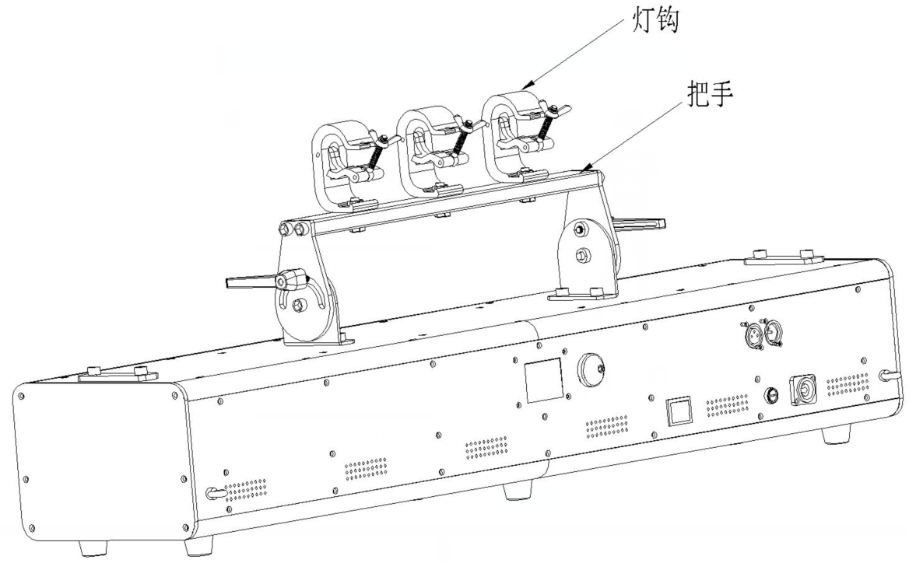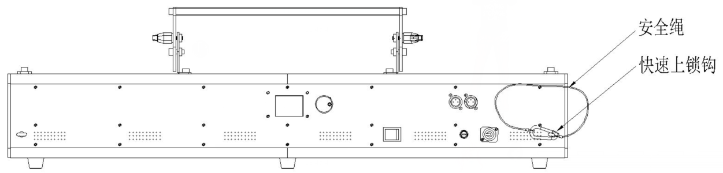

Insert the quick-lock fasteners of the first holder into the respective holes on the bottom of the device.Tighten the quick-lock fasteners fully clockwise.
Make the finished installed mounting bracket tighten on the fixed bracket.
Pull the safety rope through the holes on the bottom of the base and over the trussing system or other safe fixation spot.
Note:This step is quite important to ensure that fixture will not drop out by the damage of clamp.

Product specification
2W laser diode; average lifetime is over 2000 hours, low power consumption.
DMX channel：120CH/20CH
Control mode ：Master-Slave/Auto/DMX512/Sound
Electrical strobe: 1~23Hz；
Input voltage：AC100 ~240V 50/60Hz，
Power consumption: 150W
3pin DMX input/output, Power Con input/output
Ambient. Temp:-10°-40°

Display operation

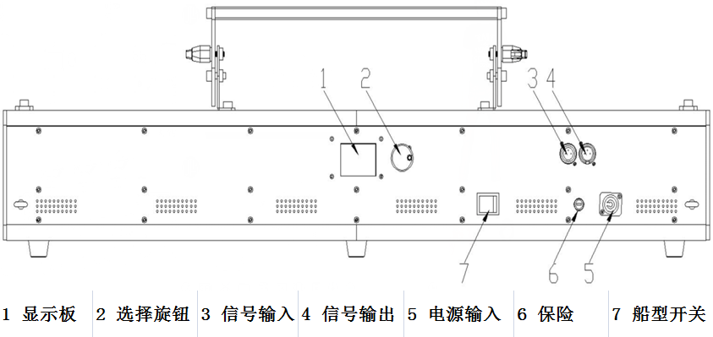

- Display board 2.Choosing knob 3.Singal input 4.Signal output 5.Power in 6.Fuse 7.Switch

MENU function setting

 | MENU | UP/DOWN | Default | Function
1 | DMX mode | Add.:1-512 | 1 | Address setting
2 | Channel mode setting | 120CH | 120CH | 120CH
2 | Channel mode setting | 20CH | 120CH | 20CH
3 | Auto mode | All effects | All effects | All effects random play
3 | Auto mode | Pattern | All effects | Pattern
3 | Auto mode | Figure | All effects | Figure
3 | Auto mode | Dot | All effects | Dot
4 | Sound mode | Sensitivity 0-9 | 8
5 | Language setting | Chinese/ENGLISH | Chinese

MENU operation

This fixture has 4 keys on panel for operation, press these keys to set DMX address, reset, edit and run programs and so on.

[MENU]: press MENU key to enter edit status, in edit status, if press MENU again, it will return the upper interface. If no operation 30 seconds after enter edit status, the fixture will exit the edit status automatically.

[Up]: press UP key, the indicator will flash, the address increases one by one, if hold the key continuously, the address will increase rapidly. If no press within 30 seconds, the indicator stops flashing and exit it. In edit status, press UP key, it will display the options circularly from down to up.

[Down]：press DOWN key, the indicator will flash, the address decreases one by one, if hold the key continuously, the address will decrease rapidly. If no press within 30 seconds, the indicator stops flashing and exit it. In edit status, press DOWN key, it will display the options circularly from up to down.

[ENTER]：in normal status, no function after press ENTER. In edit mode, press ENTER to enter lower interface.

DMX512 Channel

- 120 DMX Channel chart

Channel |  | Value | Function
CH1 | No.1 Laser total dimming | 0-255 | From dark to bright
CH2 | No.1 red laser dimmer | 0-255 | From bright to dark
CH3 | No.1 green laser dimmer | 0-255 | From bright to dark
CH4 | No.1 blue laser dimmer | 0-255 | From bright to dark
CH5 | No.1 laser strobe | 0-9 | No strobe
CH5 | No.1 laser strobe | 10-255 | Strobe from slow to fast
CH6 | No.1 laser select figure | 0-255 | Select figure
CH7 | No.1 laser figure group selecting | 0-63 | Geometrical figure group
CH7 | No.1 laser figure group selecting | 64-127 | English alphabet group
CH7 | No.1 laser figure group selecting | 128-255 | Animation decomposition figure group
CH8 | No.1 Laser zoom | 0-63 | Gobos size option
CH8 | No.1 Laser zoom | 64-127 | Gobos speed option from small to large
CH8 | No.1 Laser zoom | 128-191 | Gobos speed option from larger to small
CH8 | No.1 Laser zoom | 192-255 | Zoom speed size option
CH9 | No.1 laser gobo rotation around the center | 0-127 | Rotation angle option
CH9 | No.1 laser gobo rotation around the center | 128-191 | Clockwise rotation speed option
CH9 | No.1 laser gobo rotation around the center | 192-255 | Anti-clockwise rotation speed option
CH10 | No.1 laser gobo rotation around the X-axis | 0-127 | Gobos Pan rotation position option
CH10 | No.1 laser gobo rotation around the X-axis | 128-255 | Gobos Pan rotation speed option
CH11 | No.1 laser gobo rotation around the Y-axis | 0-127 | Gobos tilt rotation position option
CH11 | No.1 laser gobo rotation around the Y-axis | 128-255 | Gobos tilt rotation speed option
CH12 | No.1 laser pan move | 0-127 | Pan position option
CH12 | No.1 laser pan move | 128-255 | Pan move speed option
CH13 | No.1 laser tilt move | 0-127 | Tilt position option
CH13 | No.1 laser tilt move | 128-255 | Tilt move speed option
CH14 | No.1 laser track track rotation | 0-9 | No track
CH14 | No.1 laser track track rotation | 10-63 | Clockwise tracking speed from slow to fast
CH14 | No.1 laser track track rotation | 64-127 | Anti-clockwise tracking speed option from slow to fast
CH14 | No.1 laser track track rotation | 128-191 | Tilt track ,speed from slow to fast
CH14 | No.1 laser track track rotation | 192-255 | Diagonal track,speed from slow to fast
CH15 | No.1 laser wave | 0-1 | No wave
CH15 | No.1 laser wave | 2-127 | Wave phase option
CH15 | No.1 laser wave | 128-255 | Wave range and speed option
CH16 | No1.laser gobo drawing | 0-9 | no drawing
CH16 | No1.laser gobo drawing | 10-63 | gradual drawing by manual adjust
CH16 | No1.laser gobo drawing | 64-127 | auto gradual drawing （increasing）
CH16 | No1.laser gobo drawing | 128-191 | auto gradual drawing （decreasing）
CH16 | No1.laser gobo drawing | 192-255 | auto gradual drawing circularly
CH17 | No.1 laser color | 0-4 | White
CH17 | No.1 laser color | 5月9日 | Program default color
CH17 | No.1 laser color | 10-127 | Red-green-blue-yellow-cyan-pink-white(Color option)
CH17 | No.1 laser color | 128-159 | Eotic color change without subsection
CH17 | No.1 laser color | 160-191 | Eotic color change mode 1 with subsection
CH17 | No.1 laser color | 192-249 | Eotic color change mode 2 with subsection
CH17 | No.1 laser color | 250-255 | Eotic color change mode 3 with subsection
CH18 | No.1 laser color change and flow speed | 0-9 | Color no change
CH18 | No.1 laser color change and flow speed | 10-255 | Color change speed from slow to fast
CH19 | No.1 laser display | 0-63 | Normal display
CH19 | No.1 laser display | 64-127 | Brightness dot display
CH19 | No.1 laser display | 128-255 | Dot display
CH20 | No.1 laser built-in program | 0-9 | No effect(CH1-CH19 valid)
CH20 | No.1 laser built-in program | 10-127 | Built-in effect option
CH20 | No.1 laser built-in program | 128-255 | Built-in effect loop,speed from slow to fast
CH21-CH40 | No.2 laser | Value same as CH1-CH20 | Function same as CH1-CH20
CH41-CH60 | No.3 laser | Value same as CH1-CH20 | Function same as CH1-CH20
CH61-CH80 | No.4 laser | Value same as CH1-CH20 | Function same as CH1-CH20
CH81-CH100 | No.5 laser | Value same as CH1-CH20 | Function same as CH1-CH20
CH101-CH120 | No.6 laser | Value same as CH1-CH20 | Function same as CH1-CH20

- 20 CH DMX Channel chart

Channel |  | Value | Function
CH1 | No.1 -6Laser total dimming | 0-255 | From dark to bright
CH2 | No.1-6 red laser dimmer | 0-255 | From bright to dark
CH3 | No.1-6 green laser dimmer | 0-255 | From bright to dark
CH4 | No.1-6 blue laser dimmer | 0-255 | From bright to dark
CH5 | No.1-6 laser strobe | 0-9 | No strobe
CH5 | No.1-6 laser strobe | 10-255 | Strobe from slow to fast
CH6 | No.1-6 laser select figure | 0-255 | Select figure
CH7 | No.1-6 laser figure group selecting | 0-63 | Geometrical figure group
CH7 | No.1-6 laser figure group selecting | 64-127 | English alphabet group
CH7 | No.1-6 laser figure group selecting | 128-255 | Animation decomposition figure group
CH8 | No.1-6 Laser zoom | 0-63 | Gobos size option
CH8 | No.1-6 Laser zoom | 64-127 | Gobos speed option from small to large
CH8 | No.1-6 Laser zoom | 128-191 | Gobos speed option from larger to small
CH8 | No.1-6 Laser zoom | 192-255 | Zoom speed size option
CH9 | No.1-6 laser gobo rotation around the center | 0-127 | Rotation angle option
CH9 | No.1-6 laser gobo rotation around the center | 128-191 | Clockwise rotation speed option
CH9 | No.1-6 laser gobo rotation around the center | 192-255 | Anti-clockwise rotation speed option
CH10 | No.1-6 laser gobo rotation around the X-axis | 0-127 | Gobos Pan rotation position option
CH10 | No.1-6 laser gobo rotation around the X-axis | 128-255 | Gobos Pan rotation speed option
CH11 | No.1-6 laser gobo rotation around the Y-axis | 0-127 | Gobos tilt rotation position option
CH11 | No.1-6 laser gobo rotation around the Y-axis | 128-255 | Gobos tilt rotation speed option
CH12 | No.1-6 laser pan move | 0-127 | Pan position option
CH12 | No.1-6 laser pan move | 128-255 | Pan move speed option
CH13 | No.1-6 laser tilt move | 0-127 | Tilt position option
CH13 | No.1-6 laser tilt move | 128-255 | Tilt move speed option
CH14 | No.1-6 laser track track rotation | 0-9 | No track
CH14 | No.1-6 laser track track rotation | 10-63 | Clockwise tracking speed from slow to fast
CH14 | No.1-6 laser track track rotation | 64-127 | Anti-clockwise tracking speed option from slow to fast
CH14 | No.1-6 laser track track rotation | 128-191 | Tilt track ,speed from slow to fast
CH14 | No.1-6 laser track track rotation | 192-255 | Diagonal track,speed from slow to fast
CH15 | No.1-6 laser wave | 0-1 | No wave
CH15 | No.1-6 laser wave | 2-127 | Wave phase option
CH15 | No.1-6 laser wave | 128-255 | Wave range and speed option
CH16 | No1-6.laser gobo drawing | 0-9 | no drawing
CH16 | No1-6.laser gobo drawing | 10-63 | gradual drawing by manual adjust
CH16 | No1-6.laser gobo drawing | 64-127 | auto gradual drawing （increasing）
CH16 | No1-6.laser gobo drawing | 128-191 | auto gradual drawing （decreasing）
CH16 | No1-6.laser gobo drawing | 192-255 | auto gradual drawing circularly
CH17 | No.1-6 laser color | 0-4 | White
CH17 | No.1-6 laser color | 5月9日 | Program default color
CH17 | No.1-6 laser color | 10-127 | Red-green-blue-yellow-cyan-pink-white(Color option)
CH17 | No.1-6 laser color | 128-159 | Eotic color change without subsection
CH17 | No.1-6 laser color | 160-191 | Eotic color change mode 1 with subsection
CH17 | No.1-6 laser color | 192-249 | Eotic color change mode 2 with subsection
CH17 | No.1-6 laser color | 250-255 | Eotic color change mode 3 with subsection
CH18 | No.1-6 laser color change and flow speed | 0-9 | Color no change
CH18 | No.1-6 laser color change and flow speed | 10-255 | Color change speed from slow to fast
CH19 | No.1-6 laser display | 0-63 | Normal display
CH19 | No.1-6 laser display | 64-127 | Brightness dot display
CH19 | No.1-6 laser display | 128-255 | Dot display
CH20 | No.1 laser built-in program | 0-9 | No effect(CH1-CH19 valid)
CH20 | No.1 laser built-in program | 10-127 | Built-in effect option
CH20 | No.1 laser built-in program | 128-255 | Built-in effect loop,speed from slow to fast
CH20 | No.1 laser built-in program | 046-080 | G
CH20 | No.1 laser built-in program | 081-115 | B
CH20 | No.1 laser built-in program | 116-150 | R&G
CH20 | No.1 laser built-in program | 151-185 | R&B

DMX connection

Connect the provided XLR cable to the male 3-pin XLR output of your controller and the other side to the female 3-pin XLR input of the light.You can chain multiple lights together through serial linking

The cable needed should be two core, screened cable with XLR input and output connectors. Please refer to the diagram below.
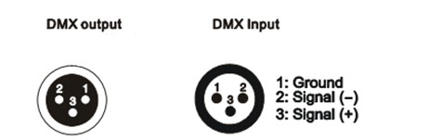
XLR Mounting socket
XLR Mounting plug

DMX address setting
Each fixture must have a specific starting address. When receiving signal transmission, fixture will receive channel control signals from DMX controller through this starting address.
According to different requirements or easy to use, the user can set many fixtures to the same address, also can set up a separately address for every device.
If more than one fixtures have the same address, all of them receive the same DMX channel signal from DMX controller. All connected fixtures are jointly controlled, DMX controller can't control a device separately.
If each device has a different address, each device will be separate and accept separate DMX512 control signal through the separate DMX address, so that more convenient to control one device separately. this method must be based on channel quantity of device to determine a starting address.
This device has 120 channels, so the first device starting address set 1, second is 120(120+1), third is 241(121+120) and so on.

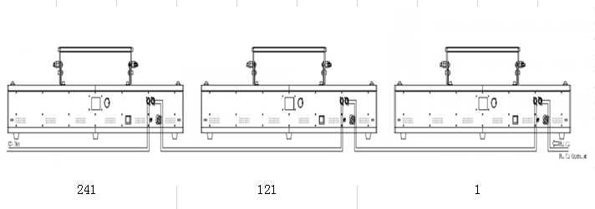

Fixture Cleaning

Maintenance should be performed every 15-day period, by using a sponge which is dipped with alcohol, rather than wet cloth or other chemical liquid, to clean the mirror.

Always disconnect from the mains when the device is not in use or before cleaning it.

Make sure power off before cleaning and maintenance!

Caution

Warning

Warning!
Never look directly into the light source,as sensitive persons may suffer an epileptic shock(especially meant for epileptics)!
Caution

Warning!
Any power connected must by professional person


Warranty Card

We will provide 1 year warranty under the condition that user has operated the light normally and lifetime service. We won't provide warranty if the damage is caused by artificial or force majeure event. Cost of fittings should be charged by user if product needs maintenance after 1 year .Please cut this warranty card and shipped it along with the product to our factory when applying for warranty.
Product： Purchasing date： Code of invoice：
Warranty date: From To
User’s name： Add：
Company： Tel：

